Name: ______________________________

**IS IT A FUNCTION?**

Finish this statement: From what I remember, a function is:



Determine if the relationships stated below represent a function.

1. (x, y) = (boys name, color of hair)
2. (x, y) = (color of hair, boys name)
3. (x, y) = (price of calculator, amount of sales tax)
4. (x, y) = (zip code of student, student height)
5. (x, y) = (miles driven since you last filled up, amount of gas in gas tank)



With your group, create 3 additional relationships. Follow the criteria below when creating the relationship.

1. Not A Function
2. Is A Function
3. Is still a function if you exchange the x and y variables.

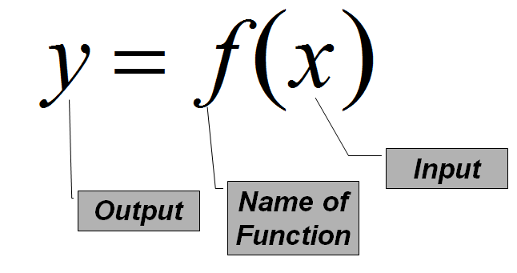**FUNCTION NOTATION**

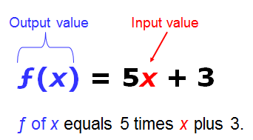

|  |  |  |
| --- | --- | --- |
| Given f(x) = x2 – 2, find:  f(5)=  f(-5)=  f(a)= | Given g(x) = 2x + 7, find:  g(4)=  g(-4)=  g(a+b)= | Given h(x) = -2x2+ 7x - 11, find:  h(2)=  h(2a)=  3h(a+b)= |

Challenge: Given $f(x) = 2x + 1$, find $-4[f(a+b) – f(1)].$

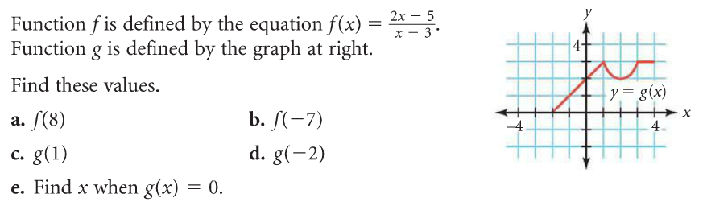**Function Notation Using a Graph**

