Math III

Cumulative Test – Spring 2017

Printed Name ______________________________

I pledge to be honest and fair. I have neither given nor received unauthorized aid on this test or assignment.

Signature: _____________________________________________________

This test is entirely calculator active.

All your work should be shown on the test however your final answers will be bubbled on a scantron sheet. If you use supplemental paper or graph paper, it must be submitted as well.



1. If *f*  is an exponential function with  and , then

a)  b)  c)  d) 

2. Let . What are the asymptotes of the function?

a) 

b) 

c) 

d) 

3. Solve 

a) $\frac{1}{25}$ b)  c)  d) 

4.Nik invested $16000 at 8% compounded quarterly for 6 years. Which formula is set up correctly?

1. 
2. 
3. 
4. 

5. Find the domain of .

a. b. c. d.

6. Which of the following is a polynomial with real coefficients that has 2-*i* and 2 as zeros?

1. (x + 2)(x – 2 – *i*)
2. (x – 2)(x + 2 + *i*)
3. (x – 2)(x2 – 4x + 5)
4. (x – 2)(x2 – 4x – 5)

7. Which of the following could be an equation for the graph below?

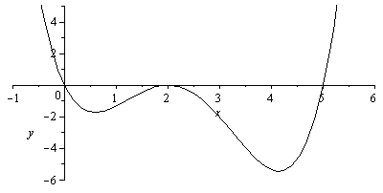

a)  b) 

c)  d) 

8. What are the real solutions to the equation ?

a)  b)  c)  d) no real solutions

9. If the population of Holly Springs was 12,000 in 1995 and grew with a yearly exponential growth rate of 3.6%, how many people to the nearest thousand would be expected to live in Holly Springs in 2010?

* 1. About 20,000 people.
  2. About  people.
  3. About 5,000 people.
  4. About 16,000 people.

10. Given that , , and , then =

a)  b) 

c)  d) 

11. The radius of the circle with equation  is

a) 36 b) 6 c) 7 d) 

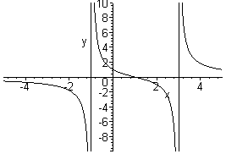12. If the graph of a rational function is given below, which equation would produce this graph?

a) 

b) 

c) 

d) 

13. Simplify completely. 

1. 
2. 
3. 
4. 
5. Use the properties of logarithms to write the expression $2\log\left(x+8\right)- 3\log{(x-5)}$ as a single logarithm.
6. 6 log(x + 8)(x – 5)
7. log(x + 8)2(x – 5)3
8. Let Find the *f* -1.

a) b) – c) both a and b d) f(x) does not have an inverse.

1. What is the explicit rule for the sequence -7, -2, 3, 8, …?
2. an = -3 + 5n b) an = -7(5)n-1 c) an = 5n – 12 d) an = -7 + 5n

17. Simplify this product completely. .

1. 
2. 
3. 
4. 

18. A single cell amoeba doubles every 4 days. How long would it take one amoeba to produce a population of about 20,000 amoebae?

1. 9.2 days b) 57.2 days c) 14.3 days d) 83.2 days

19. What is the period of y = 3 + ½ cos(8x)?

1. 4π b) 2π c) d)

20. Find the amplitude of the graph of $y=2+3 cos⁡(x- π)$.

1. a = 3
2. a = 2
3. a = π
4. a = 1

21. The price that manufacturers charge for an airplane part can be modeled by the function P(x) = 0.03x3 – 2.2x2 + 40x – 0.86. The number of parts sold can be modeled by the function N(x) = 100x2 – 78x + 12. Give an expression in standard from for the income from the sale of these parts P(x)⋅N(x).

1. 3x5 – 171.6x3 + 480x – 0.86
2. 3x5 -222.34x4 + 4171.96x3 – 3232.4x2 + 547.08x – 10.32
3. 3x3 – 2.2x2 – 38x + 11.14
4. 0.03x3 + 97.8x2 – 38x + 11.14

22. The expression (4- 6*i*)2 is equivalent to

1. – 40 b) -52 – 48*i* c) 58 d) -20 – 48*i*

23. Consider the following two normal curves:

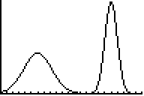

a

b

Which has the larger mean and which has the larger standard deviation?

a) Larger mean a; larger standard deviation a

b) Larger mean a; larger standard deviation b

c) Larger mean b; larger standard deviation a

d) Larger mean b; larger standard deviation b

24.Kyle found the quotient of (x4 – 2x3 + 9x – 52) ÷ (x – 3). He got a remainder of 56. What remainder should Kyle have gotten?

1. –16
2. 2
3. –160
4. He is correct, the remainder is 56.

25. Find the value of x: ${81}^{2x+1}={27}^{3x}$

a. $\frac{1}{4}$

b. $\frac{1}{2}$

c. 4

d. no real solutions

26. The income per household in a certain state is normally distributed with a mean $11400 and a standard deviation of $1650. The middle 95% of incomes are between what two values?

a) $3800 and $13,050

b) $6450 and $13,050

c) $8100 and $14,700

d) $9750 and $16,350

27. Environmental Protection Agency estimates for fuel economy for automobile models tested recently predicted a mean of 23.5 mpg and a standard deviation of 4.2 mpg for highway driving. The data is normally distributed. About what percent of cars should get between 27.7 mpg and 31.9 mpg?

1. 13.5 % b) 16% c) 95% d) 36.5%

28. Eugenia found a common denominator of 5(x – 3)(x + 3) to add which of the following rational expressions?

1. 
2. 
3. 
4. 

29. In rectangle ABCD the lengths of the sides are 16 cm and 63 cm. What is the length of a diagonal?

1. 79 cm b) 65 cm c) 47 cm d) 4225 cm

30. If m, find the value for ?

1. 50o b) 14o c) 100o d) 130o

(4x + 74) o

(5x - 20) o

A

D

C

B

31. Find the equation of the parabola with focus at (5, 9) and directrix at y = 3.

1. y = 2(x – 5)2 + 6
2. y = 4(x – 5)2 + 6
3. y = ¼ (x – 5)2 +6
4. y = (x – 5)2 + 6

32. Find the equation of the circle shown.

1. 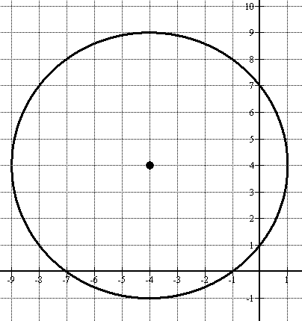x2 + y2 – 8x + 8y + 57 = 0
2. x2 + y2 – 8x + 8y + 7 = 0
3. x2 + y2 + 8x – 8y + 7 = 0
4. x2 + y2 + 8x – 8y + 57 = 0

33. Given  and, find and simplify.

1. 
2. 
3. 
4. 

34. What is the equation of the sine function in the graph shown?

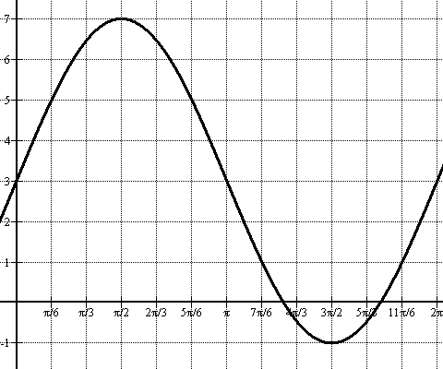

1. y = 4 sin(x) + 3
2. y = 3 sin (x) + 3
3. y = 4 sin (x) + 1
4. y = 4 sin (2x)

35. Jaclyn wants to make vases and bowls for her pottery business. Each vase takes 1 pound of clay and each bowl takes ½ pound of clay. It takes her 30 minutes to make a vase or a bowl. She has 6 pounds of clay available and 4 hours of available time. What are the constraint equations for Jaclyn’s situation? Let v = number of vases made and b = number of bowls made.

1. v + b ≤ 4 b) ½ v + ½ b ≤ 4

v + ½ b ≤6 v + ½ b ≤ 6

v ≥ 0 v > 0

b ≥ 0 b > 0

c) ½ v + ½ b ≤4 d) 30v + 30b ≤ 4

v + ½ b ≤ 6 v + 30b ≤6

v≥ 0 v≥ 0

b ≥ 0 b ≥ 0

36. Which of the following is **NOT** a rational zero of $f\left(x\right)= 2x^{3}-x^{2}-23x-20?$

1. 1 b) -1 c) 4 d) – 5/2

37. Find the x-coordinate of the solution to this system of equations: 

1. x = 1.5
2. x = 8
3. x = −2
4. x = 0.5

38. Solve the equation $\sqrt{7-3x}$ = 8.

1. x = -10 b) x = -19 c) x = 19 d) no solution

39. Solve: 9(x + 2) = 27(5-2x).

1. x = 1.1 b) x = .727 c) x = 1.6 d) x = 1.375

40. Describe the nature of the roots of x3 – 5x2 + 2x – 10.

1. 3 positive real roots OR 1 positive real root and two imaginary roots
2. 1 negative real root and 2 positive real roots OR 1 negative real root and 2 imaginary roots
3. 3 imaginary roots
4. 1 negative real root, 1 positive real root and one imaginary root

41. Determine the discriminant of f(x) = 3x2 – 7x – 48 and use it to find the type of roots of this polynomial.

1. Two rational roots
2. One real, double root
3. Two irrational roots
4. Two imaginary roots

42. Solve. 

1. x = 6
2. x = 
3. x = 12
4. No solution.

43. Convert to radians.

a. b. c. d.

44. Find the slant asymptote of the following rational function: .

a.

b.

c.

d.

45. Suppose that *p(x)* is a polynomials with degree 5 and has a root of 1 – 2*i*. Which of the following is true?

a. *p(x)* has 4 real roots.

b. *p(x)* has at least 3 real roots.

c. *p(x)* has no real roots.

d. *p(x)* has at least one real root.

46. What is the phase shift of $2+\sin\left(4(x+40)\right)=y$

a. left 40

b. right 40

c. left 10

c. right 10

47. A projectile can be modeled by the equation $y={-4.9x}^{2}+16x+8$, where *x* is time in seconds and *y* is the height of the ball in meters. At what time(s) will the ball be 19.1 meters above the ground?

a. 1 second

b. 2.3 seconds

c. both a and b

d. the ball will never reach 19.1 meters

48. The Kelvin is named after Scott Calvin from the movie series “The Santa Clause”

a. True b. False

49. The Ferris Wheel was invented for the movie “Ferris Bueller’s Day Off” – which takes place in Chicago.

a. True b. False

50. John Napier is known in the math world as the Father of Statistics. He was a pretty average guy.

a. True b. False